Ridge and Lasso Regression are two of the most popular algorithms used in the field of machine learning. Both algorithms are used to reduce the errors of a linear regression model, but there are key differences between the two which make them suitable for different types of problems.

Ridge Regression
Ridge regression is a type of regularized regression model. This means it is a variation of the standard linear regression model that includes a regularized term in the cost function. The purpose of this is to prevent Overfitting. Ridge Regression adds an L2 regularization term to the linear equation. That’s why it is also known as L2 Regularization or L2 Norm.
The main aim of Ridge Regression is to reduce Overfitting.

Graphical Intuition of Ridge Regression
Let’s say we built a linear regression model with the best-fit line passing through all the train data points.
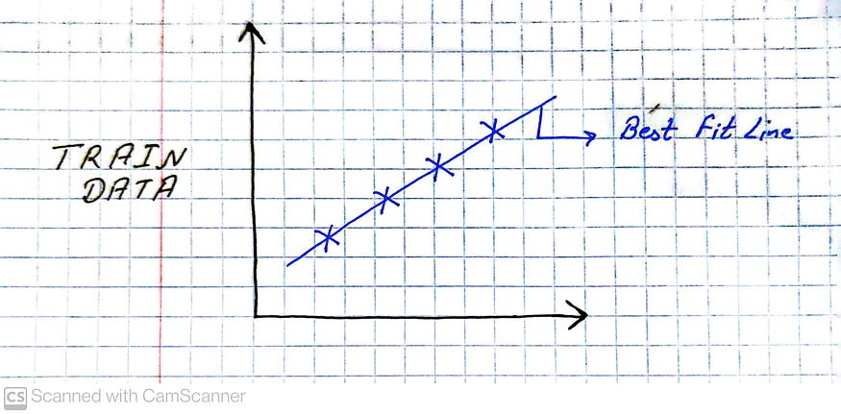
Best Fit Line passing through all Train Data Points
As the best-fit line is passing through all the train data points this means Cost Function = 0. This means that the train data will have very good accuracy but the test data will have very bad accuracy. This means it will cause Overfitting.
In order to avoid this problem or overfitting, we need to get a best-fit line with some errors or residuals. For this, we can use Ridge Regression.
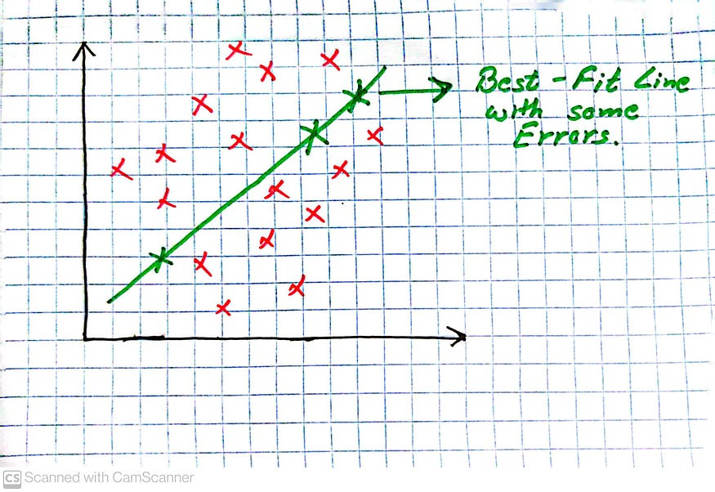
Ridge Regression

How does Ridge Regression work?
Ridge Regression works by adding a penalty term to the cost function of a linear regression model, called the regularization term. This regularization term prevents the model from overfitting by penalizing the large coefficients. The regularization parameter determines how much the model should be penalized. By increasing the regularization parameter, the coefficients are shrunk toward zero.
Cost Function (Ridge Regression)
First, let’s check the Cost Function of a linear regression model.
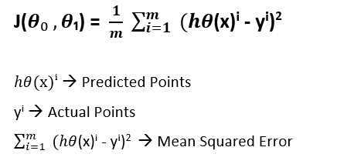
Cost Function Linear Regression
As mentioned above ridge regression adds a parameter to the linear regression cost function to avoid overfitting so the cost function of ridge regression looks like this:
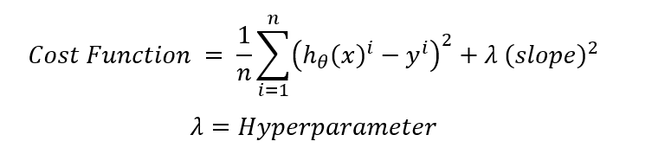
Cost Function Ridge Regression
- If λ = 0 then the cost function of Ridge Regression and the cost function of linear regression is the same.
- If even adding the hyperparameter to the original cost function the training accuracy won’t improve then it will keep on changing the value of λ and try to find the best λ parameter.
- As the cost function is changing after adding a hyperparameter, the model will also change the best-fit line.

Relationship b/w λ and slope
The slope is inversely proportional to the λ. This means as the hyperparameter λ increases slope θ decreases and vice-versa.
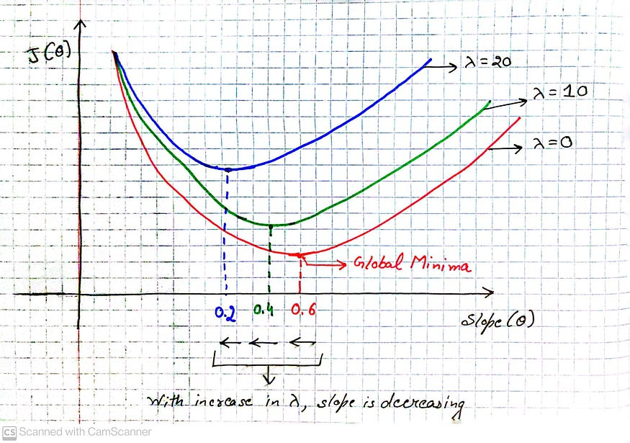
Relationship b/w λ and slope

Lasso Regression
Lasso Regression is also a type of regularization linear model. It also adds a penalty term to the cost function but it adds L1 regularization instead of L2 regularization and hence is also known as L1 Regularization or L1 Norm. This term is the sum of the absolute values of the coefficients, multiplied by a constant lambda.
The main aim of Lasso Regression is to reduce the features and hence can be used for Feature Selection.
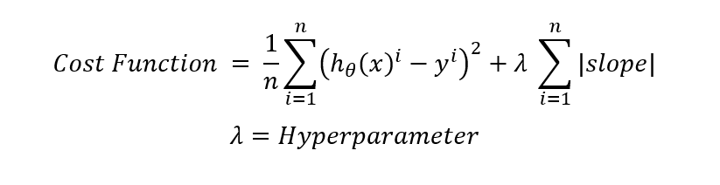
Cost Function Lasso Regression
- It is used to reduce the features because in this case slope can become zero.
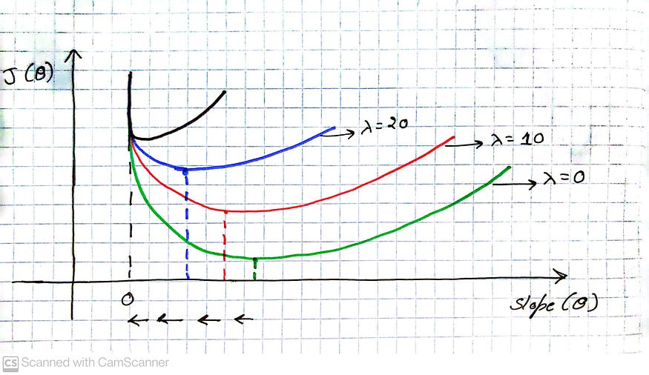
The slope can become 0
- Here, with the increase in the value of λ, the slope θ is decreasing.
- But when we will increase the value of λ again and again, at one point the slope will become 0 (hence feature will be removed), and even after that if we will increase the value of λ, the slope will be stuck at 0.

Difference b/w Ridge and Lasso Regression
The main difference between Ridge and Lasso regression is the way they shrink the coefficients. Ridge regression can reduce all the coefficients by a small amount but Lasso can reduce some features more than others and hence can completely eliminate those features.

Conclusion
Both Ridge and Lasso regression are quite popular algorithms. Ridge regression is used to avoid Overfitting while Lasso Regression can be used for feature selection. Both are regularization techniques. Both methods are useful in their own way and we can choose one over the other according to our needs.

Lasso regression and ridge regression are two popular regularization techniques used in linear regression models to prevent overfitting and improve the model's generalization performance. Both methods introduce a penalty term to the linear regression objective function, but they differ in how they penalize the coefficients of the regression variables.

Ridge Regression:

Ridge regression, also known as Tikhonov regularization, adds a penalty term to the sum of squared residuals (RSS) objective function of linear regression.
The penalty term is the L2 norm (squared magnitude) of the regression coefficients multiplied by a regularization parameter (lambda or alpha).
The L2 norm encourages the coefficients to be small, but does not force them to exactly zero.
Ridge regression shrinks the coefficients towards zero, but it rarely eliminates any of them completely.
Ridge regression can handle multicollinearity (high correlation between predictors) by reducing the impact of correlated variables on the model.
Lasso Regression:

Lasso regression, short for "Least Absolute Shrinkage and Selection Operator," also adds a penalty term to the RSS objective function, but it uses the L1 norm (sum of absolute values) of the regression coefficients.
The L1 norm encourages sparsity by forcing some coefficients to be exactly zero, effectively performing variable selection.
Lasso regression can eliminate irrelevant or redundant predictors from the model by setting their coefficients to zero.
Unlike ridge regression, lasso regression does not handle multicollinearity well and may arbitrarily select one variable from a group of highly correlated predictors.
Key Differences:

Penalty Term: Ridge regression uses the L2 norm penalty, while lasso regression uses the L1 norm penalty.
Sparsity: Lasso regression can lead to sparse solutions with some coefficients being exactly zero, performing automatic feature selection. Ridge regression tends to shrink coefficients towards zero but rarely eliminates them completely.
Multicollinearity: Ridge regression handles multicollinearity well by reducing the impact of correlated variables. Lasso regression may arbitrarily select one variable from a group of highly correlated predictors, making it less suitable for highly correlated data.
Interpretability: Lasso regression's ability to produce sparse models with fewer predictors can make the resulting model more interpretable by identifying the most important variables.
In summary, ridge regression and lasso regression are regularization techniques that help prevent overfitting in linear regression models. Ridge regression reduces the impact of all predictors by shrinking their coefficients, while lasso regression performs automatic feature selection by driving some coefficients to exactly zero. The choice between the two depends on the specific dataset, the presence of multicollinearity, and the desired interpretability of the model.
Certainly! Let's dive into the mathematical formulation of Ridge Regression and Lasso Regression.

Ridge Regression:
Ridge Regression adds a penalty term to the ordinary least squares (OLS) objective function. The objective function for Ridge Regression is defined as:
J(β) = RSS(β) + λ * ||β||²

Where:

J(β) is the objective function.
RSS(β) is the residual sum of squares, which measures the difference between the predicted values and the actual values.
β represents the regression coefficients.
λ (lambda) is the regularization parameter that controls the amount of shrinkage applied to the coefficients.
||β||² represents the L2 norm (squared magnitude) of the coefficients.
The goal is to minimize the objective function J(β) by adjusting the coefficients β. The penalty term λ * ||β||² adds a constraint that penalizes large coefficients, effectively shrinking them towards zero. The value of λ determines the amount of regularization applied: a larger λ results in greater shrinkage.

The ridge regression coefficients can be obtained by solving the following equation:

β̂(ridge) = argmin (RSS(β) + λ * ||β||²)

Lasso Regression:
Lasso Regression also adds a penalty term to the OLS objective function, but it uses the L1 norm instead of the L2 norm. The objective function for Lasso Regression is defined as:
J(β) = RSS(β) + λ * ||β||₁

Where:

J(β) is the objective function.
RSS(β) is the residual sum of squares.
β represents the regression coefficients.
λ (lambda) is the regularization parameter.
||β||₁ represents the L1 norm (sum of absolute values) of the coefficients.
Similar to Ridge Regression, the goal is to minimize the objective function J(β) by adjusting the coefficients β. The penalty term λ * ||β||₁ encourages sparsity in the coefficients, as it tends to drive some coefficients to exactly zero. Lasso Regression performs variable selection by automatically eliminating irrelevant or redundant predictors.

The lasso regression coefficients can be obtained by solving the following equation:

β̂(lasso) = argmin (RSS(β) + λ * ||β||₁)

To solve the optimization problem for Ridge Regression and Lasso Regression, various numerical methods can be used, such as gradient descent, coordinate descent, or matrix factorization techniques.
It's important to note that the mathematical formulations presented here provide a high-level understanding of Ridge Regression and Lasso Regression. The specific algorithms used to solve the optimization problems may involve additional mathematical details and computational techniques.
The regularization parameter, often denoted as \(\lambda\), is a crucial hyperparameter in regularization techniques such as Lasso regression. It controls the trade-off between fitting the training data well and keeping the model's coefficients small.
Here's a detailed explanation of the regularization parameter:
1. **Trade-off between Fit and Complexity**: In regression problems, the goal is to minimize the error between the predicted values and the actual observations. However, if the model becomes too complex (i.e., if the coefficients become too large), it might overfit the training data, capturing noise rather than true patterns. Regularization techniques like Lasso regression introduce a penalty term that discourages large coefficients, helping to control model complexity.
2. **Strength of Regularization**: The regularization parameter, \(\lambda\), controls the strength of the penalty imposed on the coefficients. A larger value of \(\lambda\) results in stronger regularization, meaning that the penalty for large coefficients is higher. Conversely, a smaller value of \(\lambda\) reduces the penalty, allowing the model to fit the training data more closely.
3. **Bias-Variance Trade-off**: Adjusting the value of \(\lambda\) affects the bias-variance trade-off of the model. A higher value of \(\lambda\) increases the bias of the model by enforcing simpler solutions with smaller coefficients. This can lead to underfitting if the model is too simple to capture the underlying patterns in the data. On the other hand, a lower value of \(\lambda\) decreases bias but increases variance, potentially leading to overfitting if the model becomes too complex.
4. **Cross-Validation**: Selecting an appropriate value of \(\lambda\) is crucial for obtaining a well-performing model. This is often done through techniques like cross-validation, where the dataset is split into training and validation sets multiple times. The model is trained with different values of \(\lambda\), and the one that yields the best performance on the validation set is chosen.
5. **Model Interpretability**: In the context of Lasso regression, the regularization parameter plays a role in variable selection. As \(\lambda\) increases, more coefficients are shrunk towards zero, effectively performing feature selection by eliminating less important variables. This can lead to a more interpretable model with fewer predictors.
the regularization parameter \(\lambda\) controls the balance between model complexity and fit to the training data. Choosing an appropriate value for \(\lambda\) is essential for building a model that generalizes well to unseen data and balances bias and variance effectively.


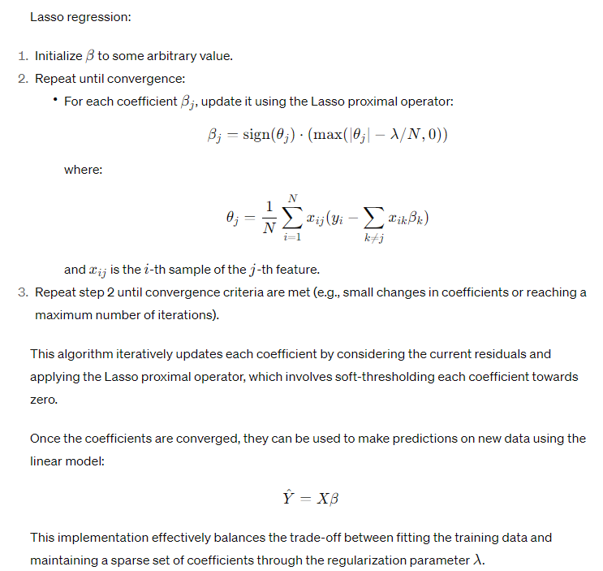

Lasso regression, also known as L1 regularization, offers several advantages, disadvantages, and specific use cases:
**Advantages:**
1. **Feature Selection:** One of the key advantages of Lasso regression is its ability to perform feature selection by driving some coefficients to exactly zero. This makes the model more interpretable and reduces overfitting by focusing on the most important features.
2. **Handles Multicollinearity:** Lasso regression can handle multicollinearity (high correlation among predictor variables) by shrinking the coefficients of correlated variables towards zero. This can help improve the stability and interpretability of the model.
3. **Simplification of Models:** Lasso regression encourages sparsity in the solution, leading to simpler models with fewer non-zero coefficients. This can improve model generalization and reduce the risk of overfitting, especially in high-dimensional datasets.

4. **Regularization:** Lasso regression effectively balances the trade-off between fitting the training data well and keeping the model simple by penalizing large coefficients. This helps prevent overfitting and improves the model's ability to generalize to unseen data.
**Disadvantages:**
1. **Arbitrariness in Coefficient Selection:** Due to the nature of the L1 penalty, Lasso regression tends to arbitrarily select one variable among variables with similar correlations, which might not always be desirable or intuitive.
2. **Instability:** Lasso regression can be sensitive to small changes in the data, leading to instability in the selected features. This instability can result in different sets of selected features when the model is trained on slightly different datasets.
3. **Unstable for Large \(p\)**: When the number of predictors (\(p\)) is much larger than the number of samples (\(N\)), Lasso regression can have stability issues, potentially selecting too few or too many features or being inconsistent in variable selection.
**Uses:**
1. **High-Dimensional Data:** Lasso regression is particularly useful when dealing with high-dimensional datasets with many features, where feature selection and regularization are important for building interpretable and generalizable models.
2. **Predictive Modeling:** Lasso regression is commonly used in predictive modeling tasks, such as regression analysis and machine learning, where the goal is to predict an outcome variable based on a set of predictor variables while controlling for model complexity.
3. **Sparse Data:** Lasso regression can handle sparse data efficiently, making it suitable for tasks involving sparse features or datasets with many zero-valued entries.
4. **Variable Selection:** Lasso regression is often used for variable selection in exploratory data analysis or when building models where interpretability and understanding of the underlying relationships are important.
Lasso regression offers advantages such as feature selection, regularization, and simplification of models, but it also has limitations related to coefficient selection arbitrariness, instability, and sensitivity to large \(p\). Understanding these advantages, disadvantages, and use cases is crucial for effectively applying Lasso regression in practice.
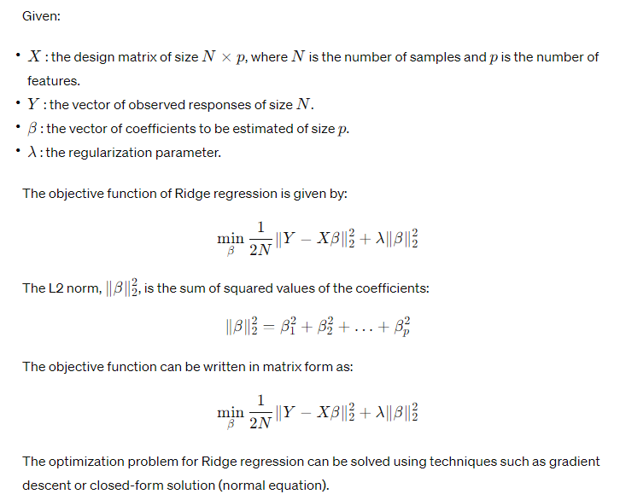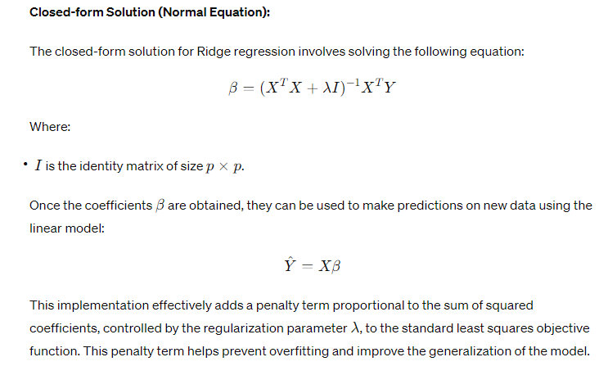

Certainly! Here's an overview of the advantages, disadvantages, and common use cases of Ridge regression:
**Advantages:**
1. **Handles Multicollinearity:** Ridge regression is effective in handling multicollinearity, a situation where predictor variables are highly correlated with each other. By penalizing the square of coefficients, Ridge regression can shrink the coefficients of correlated predictors towards each other, providing more stable and interpretable estimates.
2. **Regularization:** Ridge regression introduces a penalty term proportional to the sum of squared coefficients (L2 norm), controlled by the regularization parameter \(\lambda\). This penalty term helps prevent overfitting by penalizing large coefficient values, thus improving the model's generalization performance.
3. **Stable Coefficient Estimates:** Due to the penalty term, Ridge regression tends to produce more stable coefficient estimates compared to ordinary least squares (OLS) regression, especially when dealing with high-dimensional datasets or datasets with multicollinearity.
4. **Improves Numerical Stability:** Ridge regression can improve the numerical stability of the model estimation process, particularly when dealing with ill-conditioned or singular design matrices. It adds a positive constant to the diagonal elements of the design matrix, which can help alleviate numerical issues during inversion.
**Disadvantages:**
1. **Bias in Coefficient Estimates:** Ridge regression introduces a bias in coefficient estimates by shrinking them towards zero. While this bias can help reduce overfitting and improve generalization, it may lead to a loss of sensitivity to small but true effects in the data, particularly if the true coefficients are close to zero.
2. **Not Suitable for Feature Selection:** Unlike Lasso regression, which can perform feature selection by driving some coefficients exactly to zero, Ridge regression only shrinks the coefficients towards zero without setting them exactly to zero. As a result, Ridge regression may not be suitable for tasks that require feature selection.
**Uses:**
1. **Regularization in Linear Models:** Ridge regression is commonly used as a regularization technique in linear regression models, especially when dealing with multicollinearity or overfitting issues. It helps balance the bias-variance trade-off by controlling the complexity of the model through the regularization parameter.
2. **Predictive Modeling:** Ridge regression is widely used in predictive modeling tasks where the goal is to predict an outcome variable based on a set of predictor variables. It can improve the model's generalization performance by preventing overfitting and stabilizing coefficient estimates.
3. **High-Dimensional Data:** Ridge regression is particularly useful when dealing with high-dimensional datasets with many predictors, where multicollinearity and overfitting are common challenges. It can provide more reliable and interpretable estimates compared to ordinary least squares regression in such scenarios.
4. **Improving Numerical Stability:** Ridge regression can be used to improve the numerical stability of model estimation procedures, especially when dealing with ill-conditioned or singular design matrices. It can help mitigate numerical issues such as matrix singularity or large condition numbers.
Ridge regression offers advantages such as handling multicollinearity, providing stable coefficient estimates, and improving numerical stability. However, it introduces bias in coefficient estimates and may not be suitable for feature selection tasks. It is commonly used as a regularization technique in linear regression models, especially in predictive modeling tasks with high-dimensional data or multicollinearity.
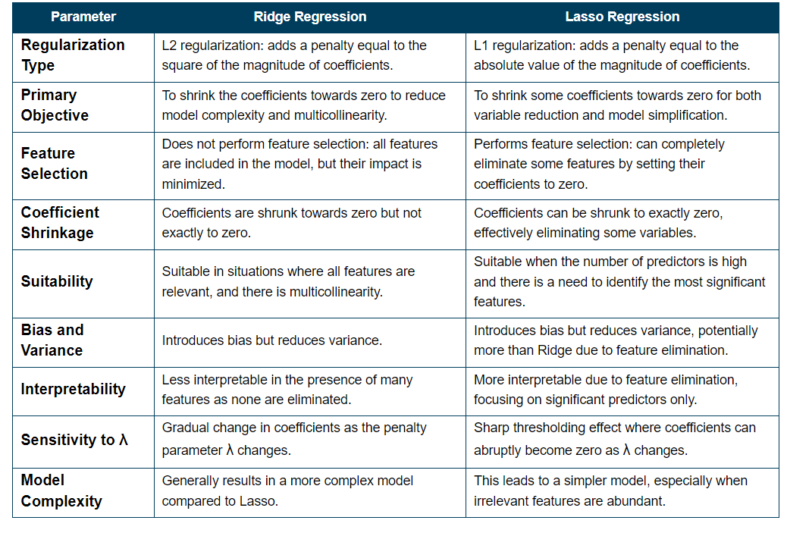
Here's a breakdown of the points discussed in the article "Lasso Regression causes sparsity while Ridge Regression doesn’t! – Unfolding the math":

1. **Introduction**: The article aims to explain the difference between Lasso regression and Ridge regression in terms of inducing sparsity in the model's coefficients.

2. **Sparsity and Regularization**: Regularization techniques like Lasso and Ridge regressions are used to combat overfitting by properly selecting features. Lasso achieves this by completely diminishing the importance of some features (resulting in sparsity), while Ridge reduces the importance of features without nullifying them.

3. **Unfolding the Math**:
- **Ridge Regression (L2)**: Ridge regression minimizes a function comprising the squared error and a regularization term (L2 norm). It's shown mathematically that Ridge regression does not lead to sparsity, as the coefficients never become exactly zero.
- **Lasso Regression (L1)**: Lasso regression minimizes a function with a regularization term (L1 norm), which is not continuous and not differentiable at the point of discontinuity. The discontinuity can occur at β=0, leading to sparsity.

4. **Example**:
- Ridge Regression: It's explained that Ridge regression shrinks larger coefficients more, leading to a significant change in the penalty function.
- Lasso Regression: In Lasso regression, both coefficients have to be shrunk to achieve regularization, and some coefficients may shrink to zero.

5. **End Points**: The article concludes by emphasizing the importance of understanding regularization techniques like Lasso and Ridge regression, which play a crucial role in feature selection and model interpretability. It highlights the complexities involved in visualizing these concepts in higher dimensions.

In summary, the article provides insights into the mathematical underpinnings of Lasso and Ridge regressions and explains how they induce sparsity differently in the model's coefficients. It aims to demystify these concepts and provide a deeper understanding of regularization techniques in linear regression.

